Discussion Groups

Eden Restored

Kingdom Conference 2020

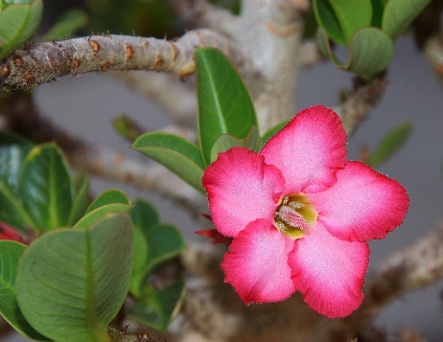
Discussion Group 3: Eden Restored

‘He will make her wilderness like Eden and her desert like the garden of Yahweh’
How was the world different before ‘the fall’ (Genesis 3) to now?

What will the world be like during the 1000 years reign of the Kingdom?

How will the animals change?

How will the transformation of the world take place?

What is the picture in Ezekiel 47?
Where does the river come from if it is not present today?

What does this picture represent? What are the spiritual lessons?

How can we have a stronger vision of Eden restored?

Bonus questions
Which aspect of Eden restored are you most looking forward to seeing?

Any other questions about Eden restored that you would like to discuss?

